The Reflection to Unit 1

I. Decide whether the following statements are true (T) or false (F):
_____ 1. The UK includes 3 constituent nations: England, Scotland, and Wales.
_____ 2. London is the largest city not only in the UK but also in the European Union.
_____ 3. New York is the capital of the US.
_____ 4. Canada is described as a “melting pot”.
_____ 5. There are three-tier systems of Australian government
_____ 6. Ontario is the major French-speaking province of Canada.
_____ 7. The British Queen is also head of state of fifty other Commonwealth countries, such as Canada, Australia and New Zealand.
_____ 8. In GDP per capita, the US ranks the 1st globally.
_____ 9. Australia is the world smallest continent.
_____ 10. New Zealand gains the reputation of the world’s largest farm, which is only for pastoral use.
_____ 11. The US has a market-oriented and free economy, without government intervention.
_____ 12. New Zealand is a world leader in agriculture research and horticulture.
_____ 13.Compared with the Western Europe countries, the living standard of New Zealand is relatively low.

II. Please match the following parts of the UK.
England
Scotland
Wales
Northern Ireland

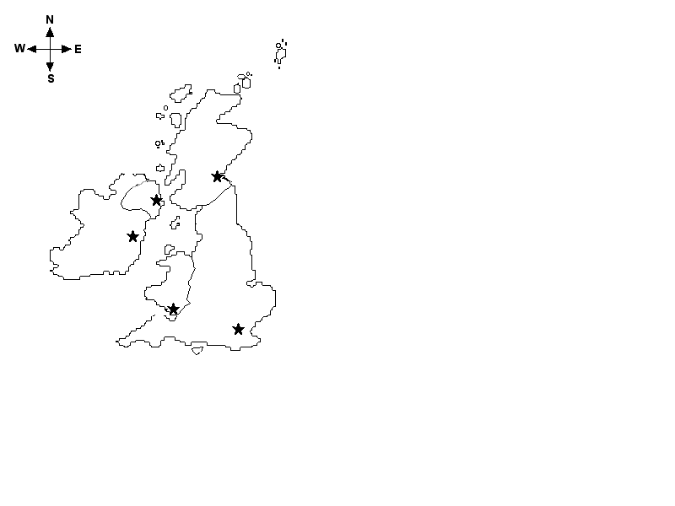

III. Multiple choices
1. Which of the following is the largest and most populous constituent part of the UK?
A. England B. Scotland C. Wales D. Northern Ireland

2. Which of the following is a characteristic of London?
A. The political centre. B. The financial centre.
C. The cultural centre. D. All the above.

3. Which of the following is the largest country in physical size?
A. the US B. Canada C. Australia D. New Zealand

4. Which city is the global center of finance, culture and fashion?
A. London B. New York C. Toronto D. Sydney

5. Which of the following is NOT characteristic of British government?
A. It is both a parliamentary democracy and a constitutional monarchy.
B. It has no written form of Constitution.
C. The Queen has extensive theoretical powers, but her role is mainly ceremonial.
D. The Queen has high political status and supreme executive power.

6. Which of the following country has more lakes than any other one?
A. the US B. Canada C. Australia D. New Zealand
7. Which country’s government was not based on the British system of parliamentary democracy?
A. the US B. Canada C. Australia D. New Zealand

8. What is the other official language besides English in Canada?
A. Spanish B. French C. Maori D. Chinese

9. Which of the following is NOT one of the major exports of New Zealand?
A. Dairy products B. Fish C. Wool D. Oil

10. Which of the following is NOT a power of the US president?
A. The president can make laws.
B. The president appoints the Cabinet and other senior officers.
C. The president can propose legislation to Congress.
D. The president has broad authorities in running the government departments and handling foreign relations.

VI. Group work
Discussion:
- Are there any differences between England, Scotland and Wales in terms of cultural tradition?
- Give examples to the declining industries in the UK, as well as industries that are fast developing.
- What contributes to the fast expansion of American economy?
- Please find out similarity and differences in terms of geography between Australia and New Zealand.

The Keys to the Text of Unit 1
I. Decide whether the following statements are true (T) or false (F):
1-5. F T F F T
6-10 F T F T F
11-13 F T F

III. Multiple Choices
1-5 A D B B D
6-10 B A B D A

